Task4_wireshark_basic

4.1

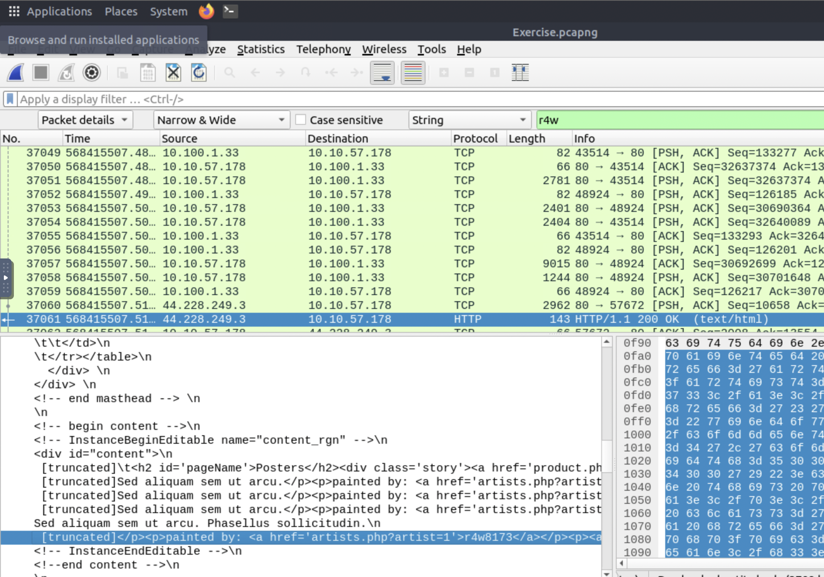

4.2

This question is quite complicated. 1st – look into comment section of packet 12.

Its says go to packet 39765

2nd – go the packet 39765 and export the packet and store it on desktop

3rd – use md5sum on the save packets - you will get the answer

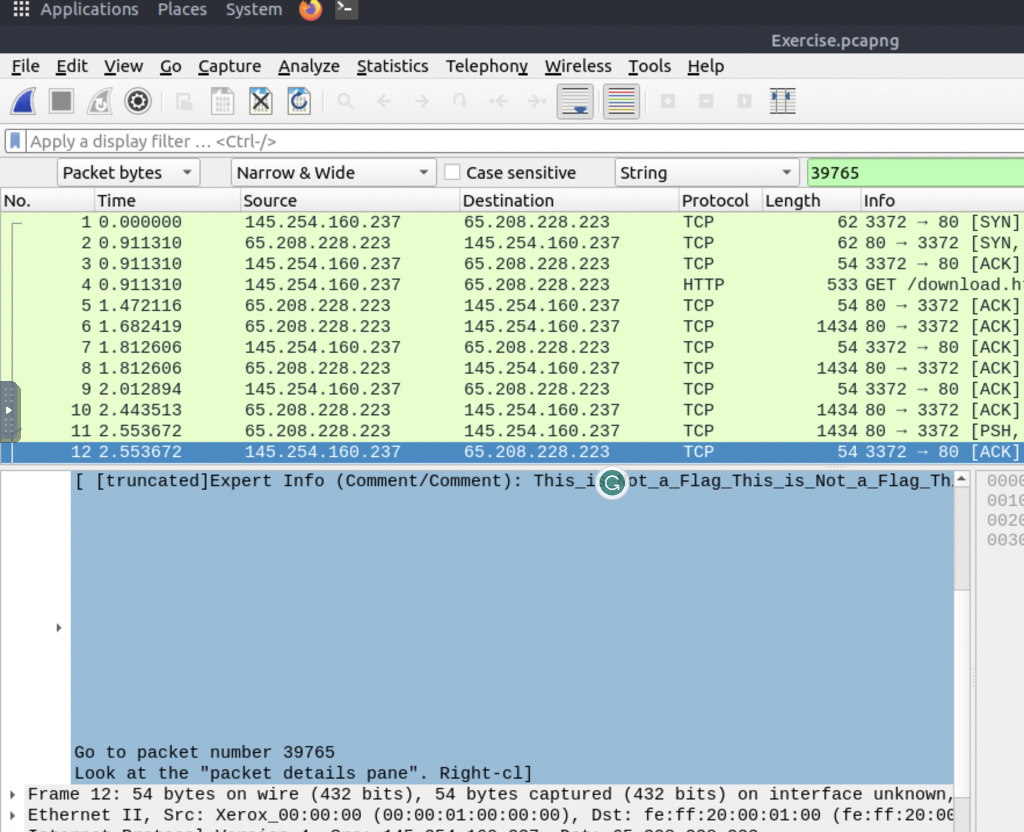

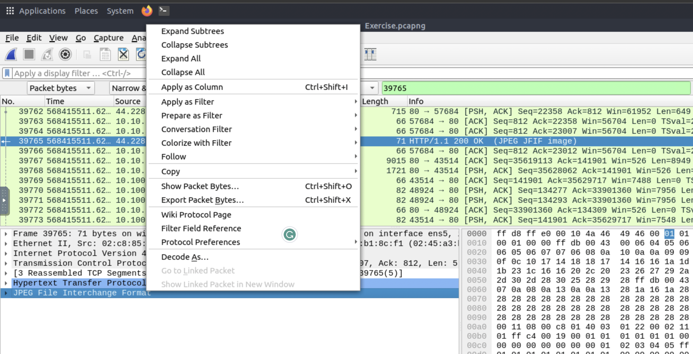

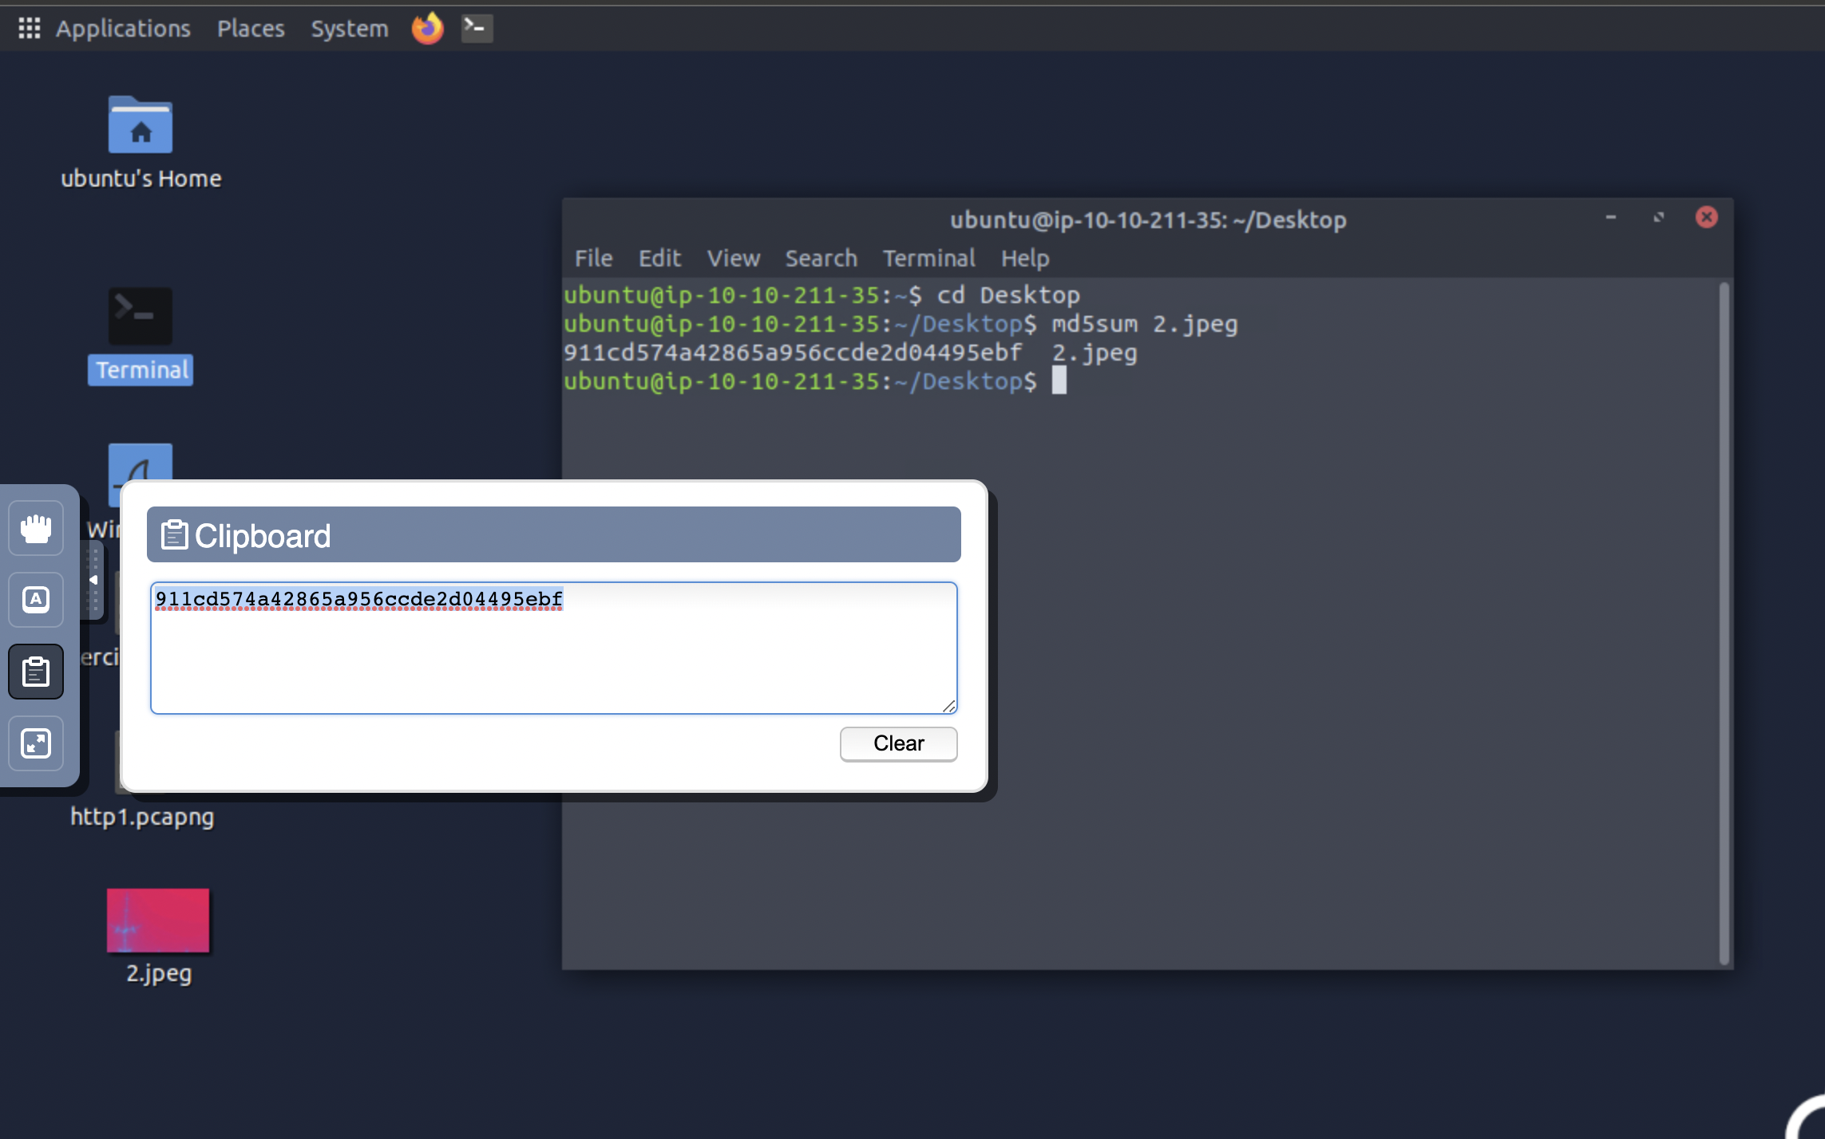

4.3

Search packet .txt . Analyze it packet in line based text data you will find the answer - packetmaster

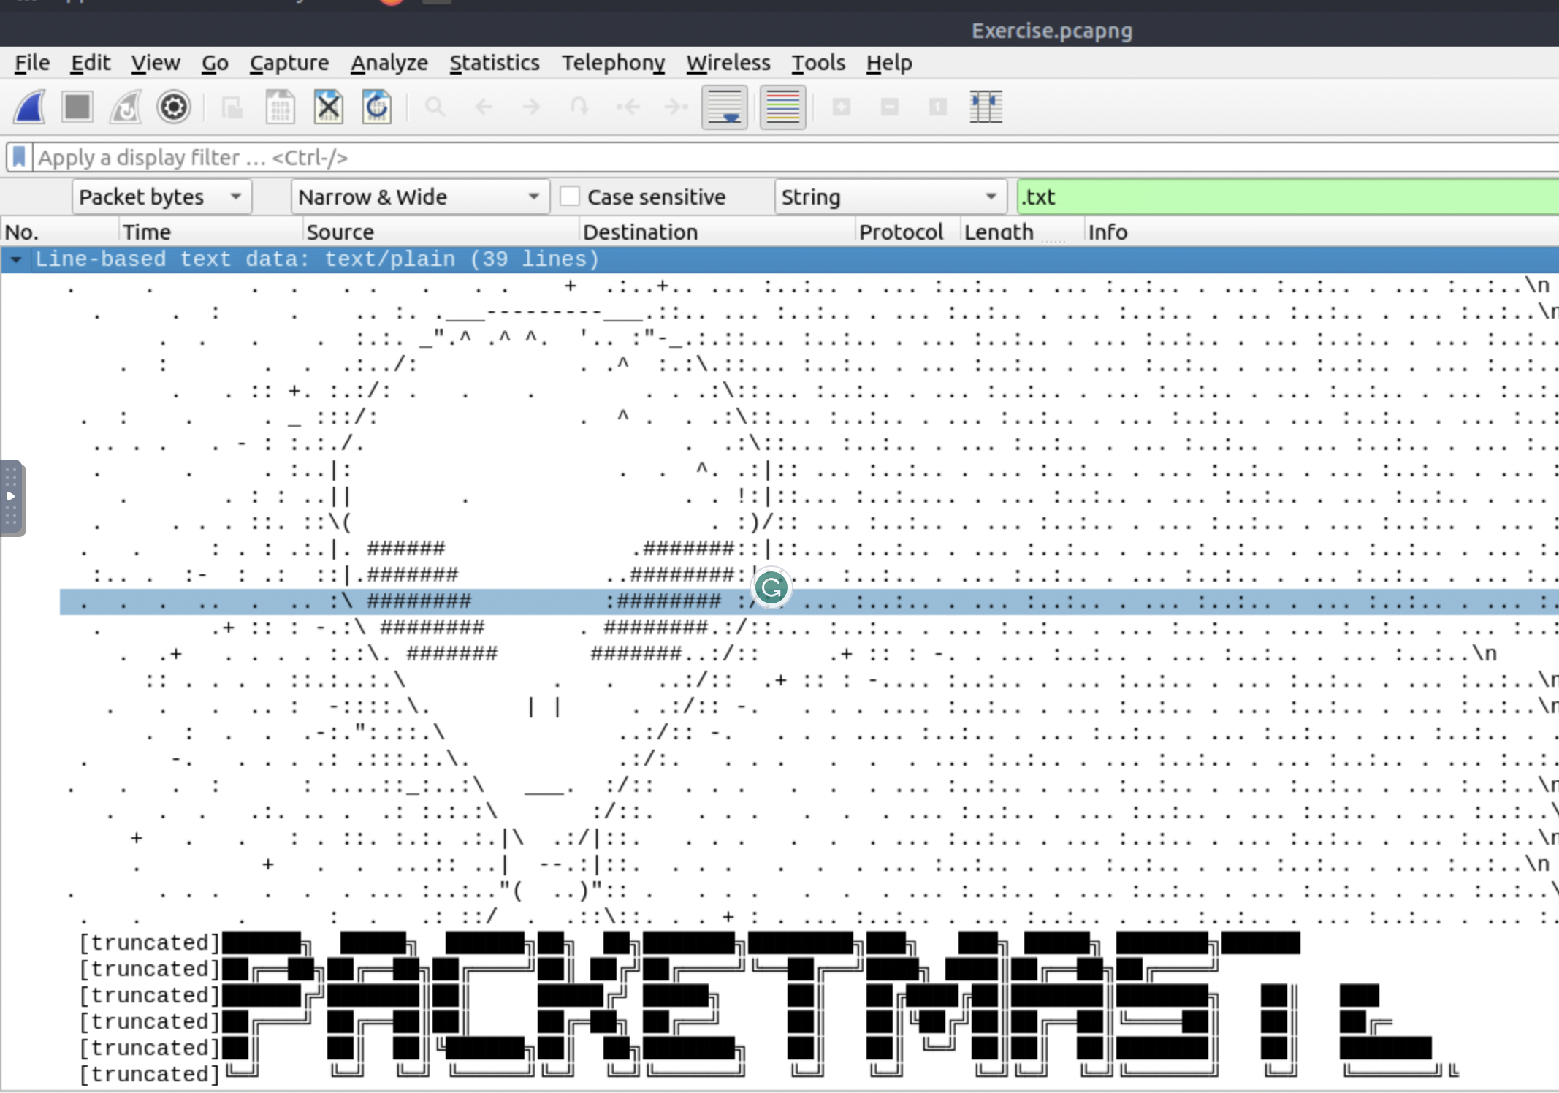

4.4

